FINAL PRACTICAL EXAM

PRM393

Duration
90 Minutes

Allowed Resources
Students are allowed to use AI Tools:

Objective
This exam does NOT evaluate memorization of Flutter syntax.
This exam evaluates:
- Software design skills
- AI-assisted development skills
- Code review skills
- Debugging skills
- System thinking
- Ability to understand and improve existing code
- Ability to explain technical decisions
Students are free to use AI tools. However, students must be able to explain and justify their solutions.

Scenario
You are a Flutter Developer working for an online smartphone store.
During development, the Product Owner continuously changes requirements.
You must build features, adapt to requirement changes, review source code, and justify your technical decisions.

PART A – SYSTEM DESIGN (15 POINTS)
API Endpoint:
https://dummyjson.com/products/category/smartphones

Task A1 – Architecture Design
- 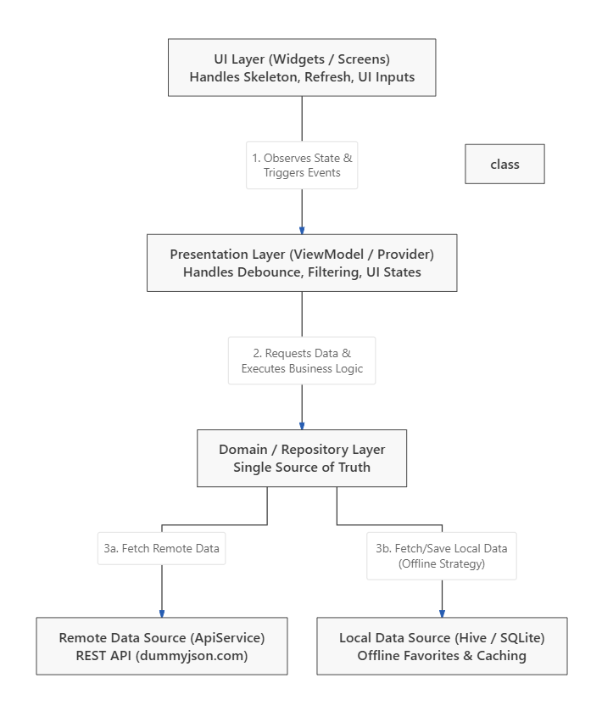

Task A2 – Design Questions

1. Why should API calls not be made directly inside Widgets?
- Violation of Separation of Concerns (SoC): Widgets should strictly handle UI rendering and presentation. Mixing networking logic into the view layer makes the codebase tightly coupled, cluttered, and difficult to maintain.
- Performance Issues (Duplicate Requests): Widgets rebuild frequently due to framework lifecycles, user interactions, or screen orientation changes. Placing API calls directly inside a widget risks triggering unintended duplicate network requests, wasting bandwidth and server resources.
- Testability: Tightly binding network operations to the UI lifecycle makes it nearly impossible to write isolated, deterministic Unit Tests for your business logic.

2. If the API URL changes tomorrow, which layer should be affected?
- Only the ApiService (within the Remote Data Source) layer will be affected.
- Because network endpoints are centralized and encapsulated within a dedicated service class, you only need to update the configuration or URL string in that single location. The higher layers (Repository, ViewModel, and UI) remain completely unaffected and untouched.

3. If offline caching is required, where would you add it?
- Offline caching logic should be implemented inside the Repository layer.
- Mechanism: The Repository acts as the mediator between different data sources. When the app requests data, the Repository handles the orchestration logic:
  - If internet is available: It fetches the latest data via the Remote Data Source, overwrites the stale cache in the Local Data Source (Database), and passes the fresh data up to the UI.
  - If network is unavailable: It gracefully falls back to fetch the cached data from the Local Data Source, ensuring an uninterrupted user experience.

4. If the backend changes from REST to GraphQL, how would your design help?
- This architecture leverages the power of Abstraction through the Repository Pattern.
- UI & State Protection: The ViewModel interacts purely with an abstract repository contract (e.g., calling repository.getProducts()). It is entirely agnostic to the underlying networking protocol. Consequently, 100% of your presentation and state management code stays intact.
- Swappable Data Layer: You only need to implement a new GraphQLApiService to replace the old RestApiService inside the Data layer. The rest of the application will continue to function seamlessly without any ripple effects.

PART B – BUILDING THE MVP (20 POINTS)
Build a Product List screen.
Display:
- Product image
- Product name
- Product price
- Product rating

Mandatory Requirements
- Skeleton Loading
- Pull-to-Refresh
- Error State
- Empty State

Not Allowed
Using CircularProgressIndicator as the primary loading solution.

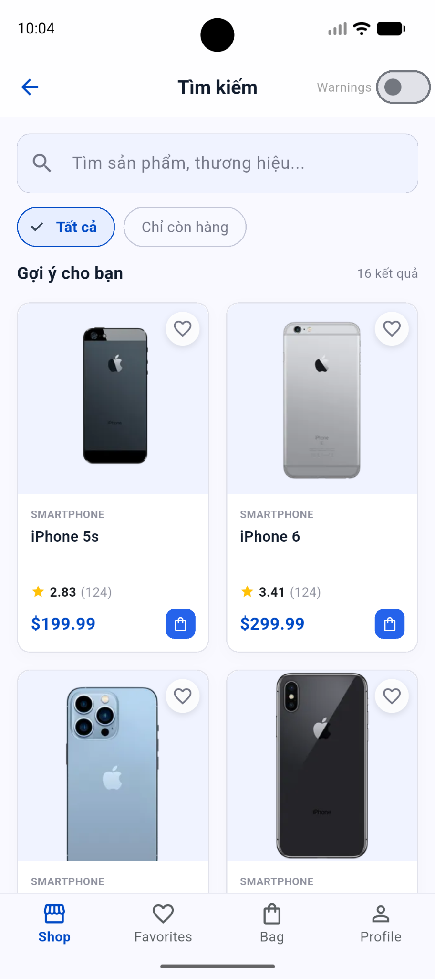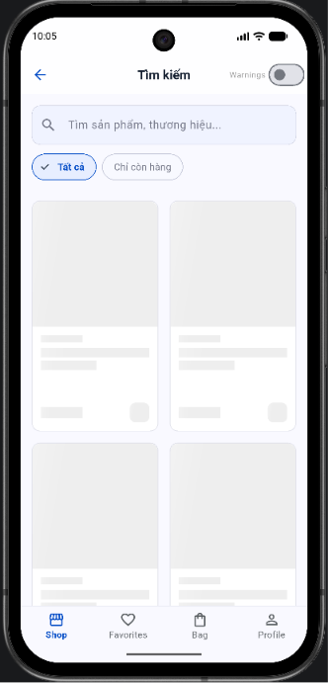
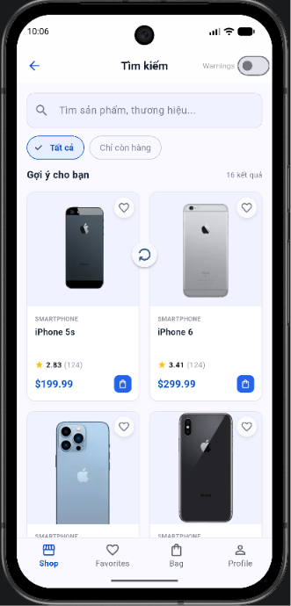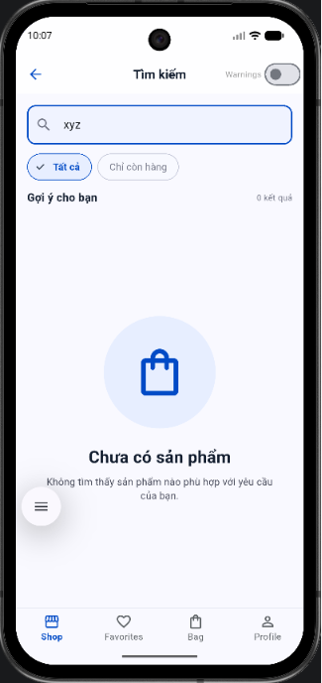

PART C – CHANGE REQUESTS (15 POINTS)
After completing the MVP, the Product Owner introduces the following changes.

Change Request #1
Display only products that are in stock.

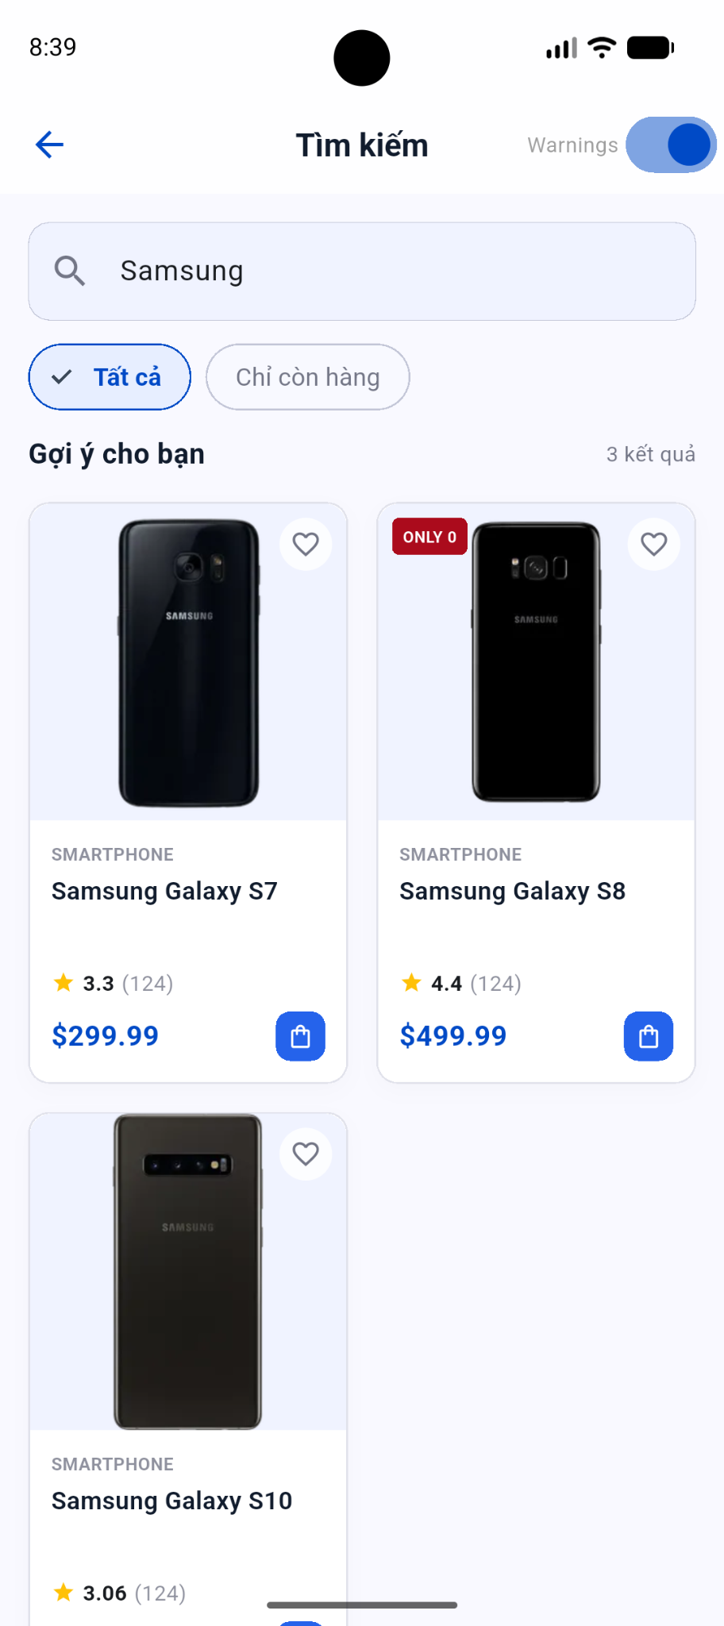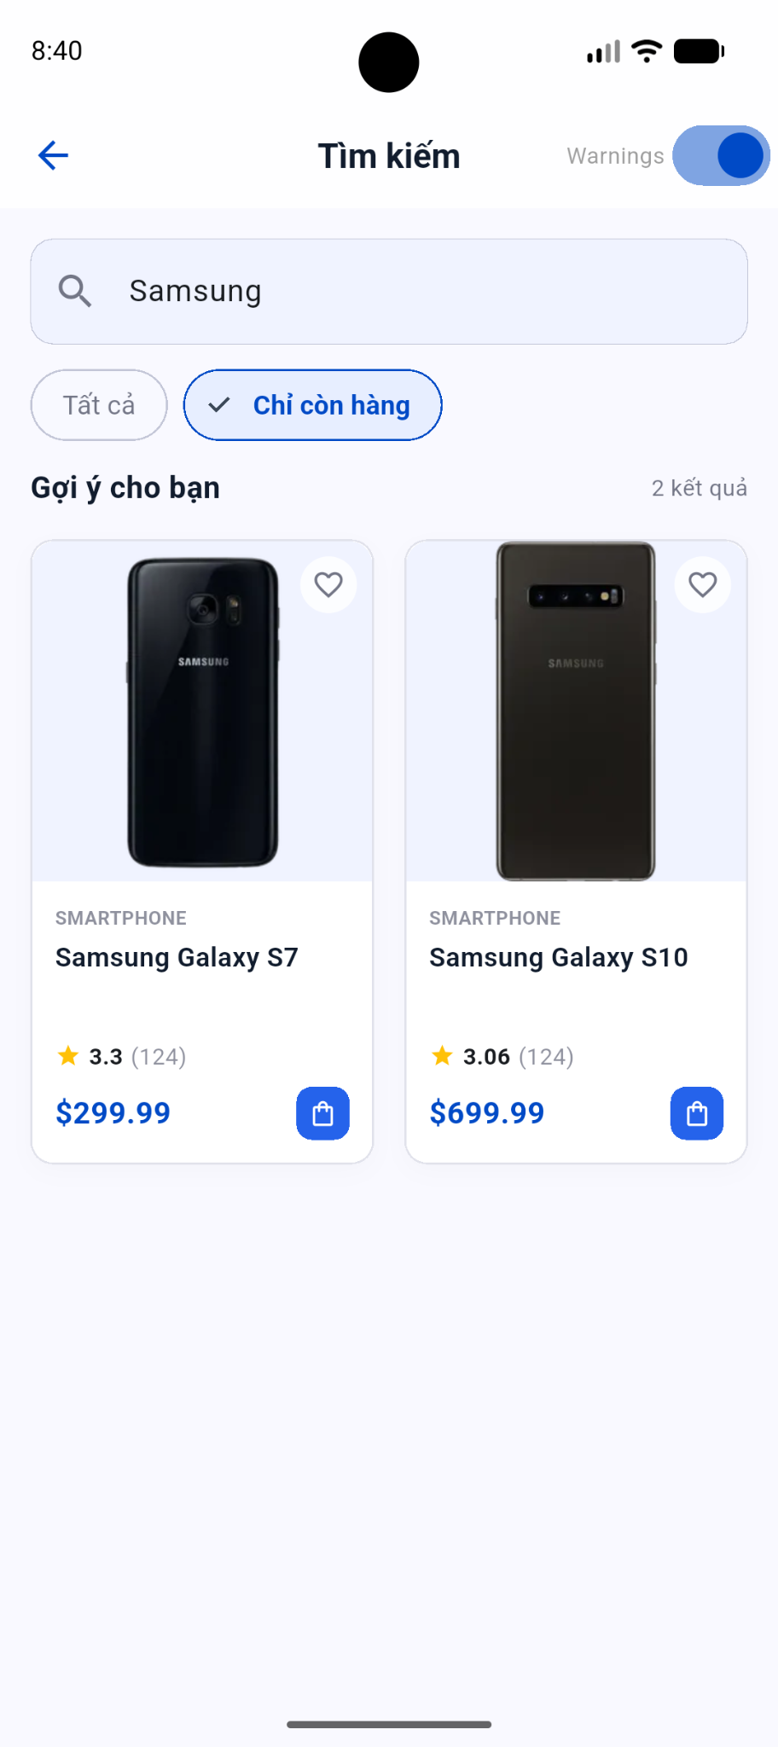

Change Request #2
If stock < 10, display a red warning label.

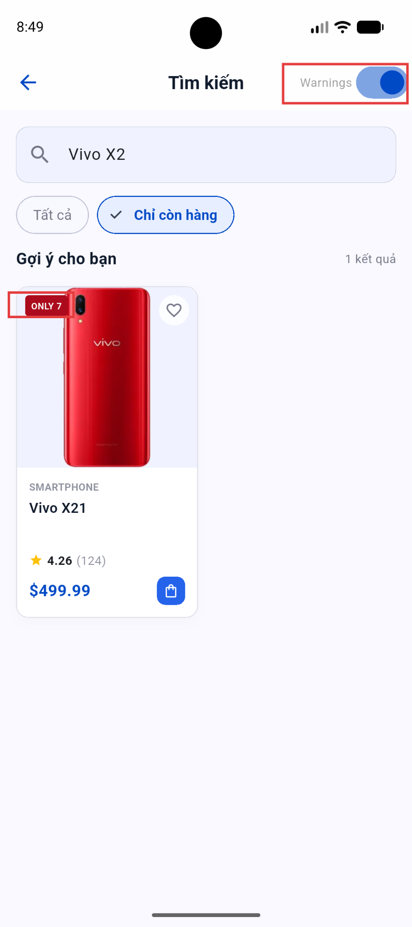

Change Request #3
Allow users to enable/disable stock warnings.

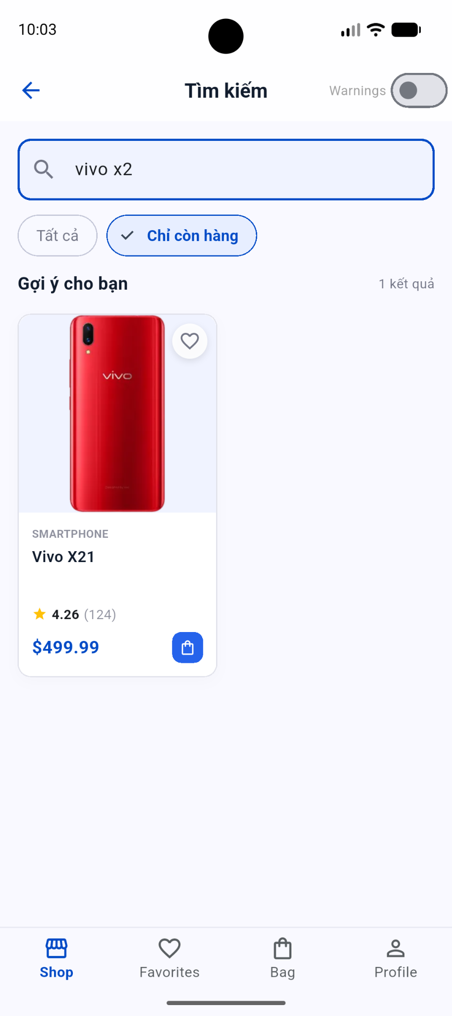

Change Request #4
Add product search functionality.

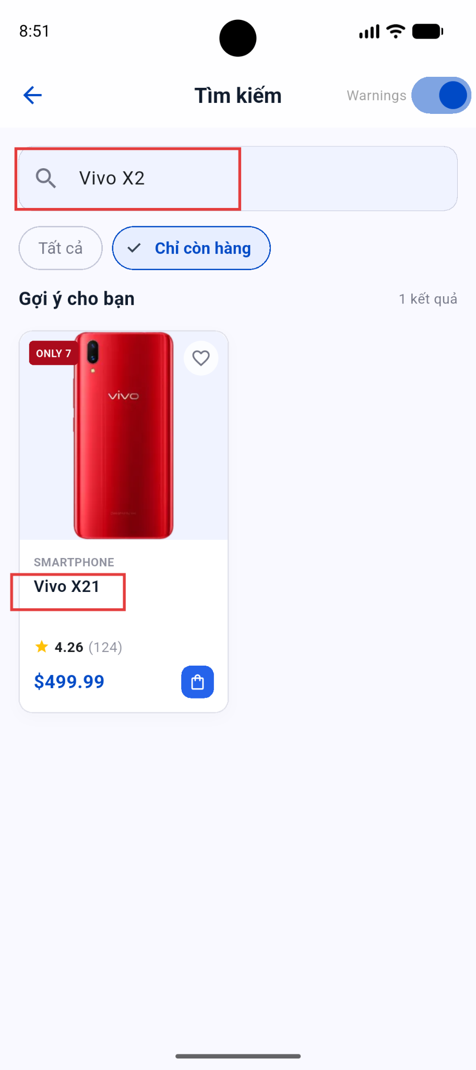

Change Request #5
Implement a 500ms debounce for search.


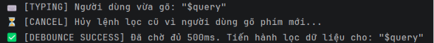
Console: Nó KHÔNG hề in ra 6 dòng log (s, sa, sam,...). Nó chỉ in ra đúng một dòng duy nhất: flutter: 🔍 [DEBOUNCE DEMO] Đang lọc dữ liệu cho từ khóa: "Samsung"

"Dear Teacher, normally, without a Debounce mechanism, every single keystroke in the search bar triggers the filter function immediately. For instance, if a user quickly types the word 'oppo' (4 characters), the application has to perform the data filtering calculation 4 consecutive times, which causes UI lagging and drains the battery."
"To optimize performance, I implemented a Timer to introduce a 500ms (half a second) delay. As long as the user keeps typing continuously, the previous filter command is immediately canceled using _debounce!.cancel(). The filtering logic is only executed when the user STOPS TYPING for more than half a second."

Additional Analysis Questions
Assume the application must handle:
1,000,000 products.
Answer:
- Is your current implementation still appropriate?
- Why or why not?
- Propose at least two alternative solutions.

1. Is your current implementation still appropriate?
No, it is no longer appropriate.

2. Why or why not?
The current implementation fetches all products at once from the API, stores them in a Dart List<Product>, and performs searching/filtering purely on the client side (using .where()). While this works perfectly for an MVP with 20-50 products, scaling it to 1,000,000 products will cause catastrophic failures:
- Memory Exhaustion (OOM): Loading 1,000,000 complex objects (with strings, doubles, and booleans) into the mobile device's RAM will instantly crash the app due to OutOfMemory exceptions.
- Network Bottleneck: Downloading a JSON payload containing 1 million items will consume massive amounts of bandwidth and time, resulting in poor UX and high risks of connection timeouts.
- UI Thread Blocking (Jank): Dart runs on a single thread by default. Iterating through 1,000,000 items locally during the searchProducts function will completely block the UI thread, freezing the screen and making the app unresponsive.

3. Propose at least two alternative solutions:
Solution 1: Server-Side Pagination and Searching (Best Practice) Instead of loading all products, shift the heavy lifting to the backend database.
- Pagination / Infinite Scrolling: Fetch data in small chunks (e.g., 20 products per request) using query parameters like ?limit=20&skip=0. As the user scrolls down the GridView, make subsequent API calls to load the next chunk.
- Backend Filtering: The search and "in-stock" filter logic must be handled by the server. When the user types a keyword, the app sends a request to a search endpoint (e.g., api/products/search?q=query&inStock=true), and the backend returns only the limited subset of matching results.
Solution 2: Local Database with Dart Isolates (For Offline-First Architecture) If the business requirement dictates that all 1,000,000 products must be accessible offline:
- Local DB Engine: Store the data in a highly optimized local database like SQLite or ObjectBox instead of a Dart List. When the user searches, run an indexed SQL query (e.g., SELECT * FROM products WHERE title LIKE '%query%' LIMIT 20) which is infinitely faster and memory-efficient.
- Background Threads (Isolates): Any heavy JSON parsing or large data processing should be moved off the main thread using Dart Isolates (or the compute() function) to ensure the UI remains smooth and 60FPS.

PART D – FAVORITE FEATURE (OFFLINE + UI CLONE) (10 POINTS)

Task Description
Implement a Favorite Screen with the following requirements:
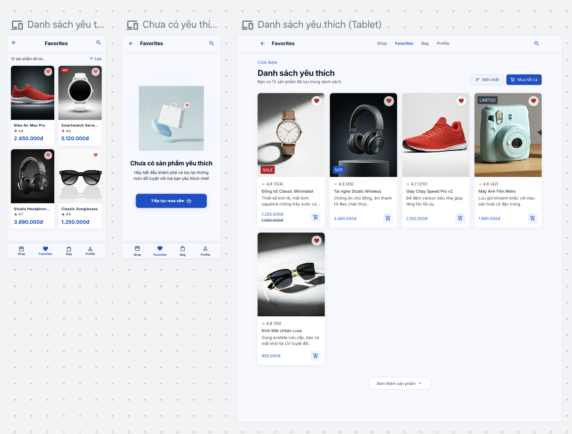

Feature Requirements
- Users can add/remove favorite products
- Favorites must be stored offline (local storage)
  - Suggested: Hive / SharedPreferences / SQLite
- Favorite data must persist after app restart
- Must work without internet connection

UI Requirements (MANDATORY)
You must build a UI similar to the design below:

Favorite Screen Includes:
- List of favorite products
- Product image
- Product name
- Price
- Remove (heart icon / delete button)
- Empty state (No favorites)

IMPORTANT
- UI must be visually similar (layout + spacing + structure)
- You are allowed to customize colors slightly
- You must not change layout structure

Task D1 – UI Implementation
📸 Screenshot your Favorite Screen
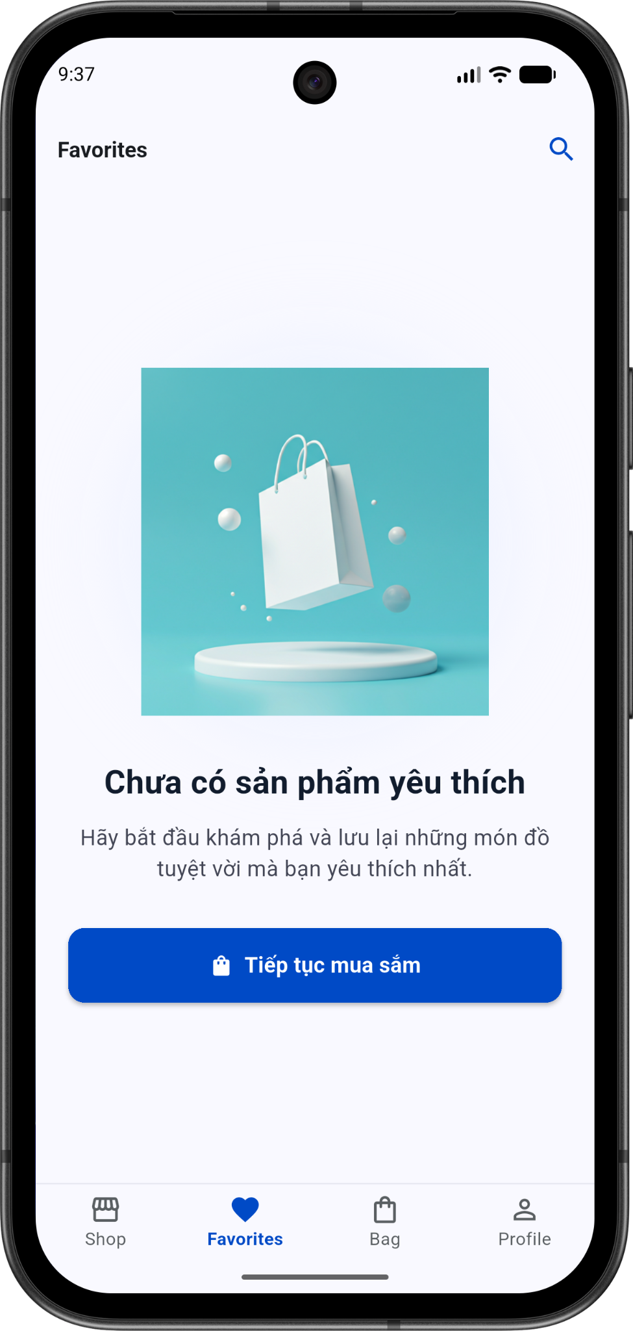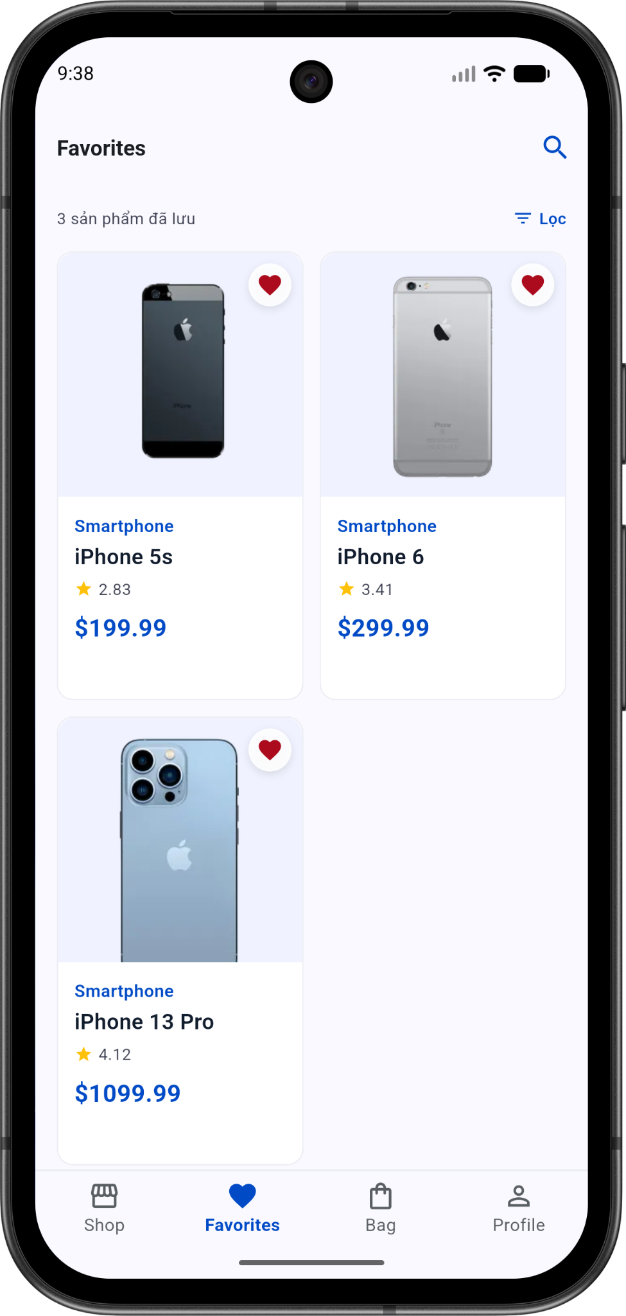

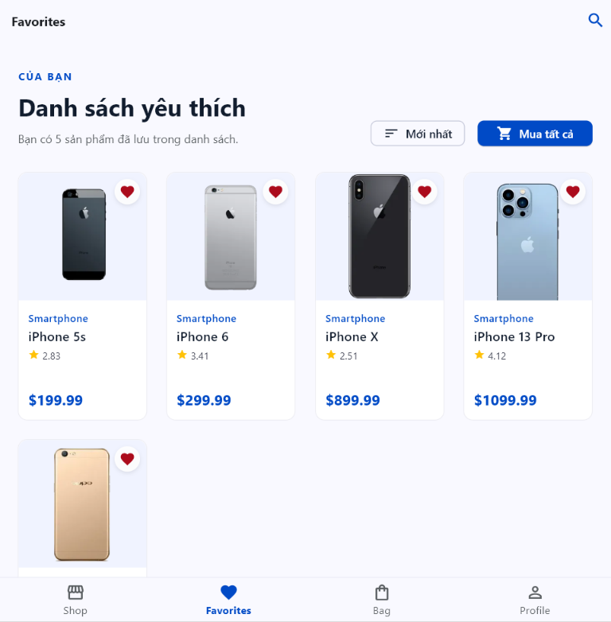

Task D2 – Offline Strategy
Answer:
- Where is favorite data stored?
- Why did you choose that solution?
- How does your architecture support offline-first?
Answer:
1. Where is favorite data stored? The favorite data is stored locally on the device's persistent storage using the shared_preferences package. Specifically, the list of favorite Product objects is serialized into a JSON string array and saved as a key-value pair under the key 'favorite_products'.
2. Why did you choose that solution? I chose SharedPreferences because it is highly efficient and perfectly suited for the scope of this feature. The favorite products dataset is relatively small, unstructured, and only requires simple Read/Write operations. Using a full SQL database (like SQLite) or a NoSQL engine (like Hive) would introduce unnecessary boilerplate, overhead, and complexity for an MVP. SharedPreferences provides a lightweight, frictionless, and synchronous-like approach that is more than capable of handling list serialization with near-zero latency.
3. How does your architecture support offline-first? The application strictly follows the MVVM architecture combined with the Repository Pattern to enable seamless offline-first capabilities:
- Encapsulation (Repository): The FavoriteRepository encapsulates all direct interactions with local storage, abstracting away the JSON encoding/decoding process. The rest of the app has no idea how the data is stored, only that it is reliably available.
- Eager Loading (ViewModel): Upon initialization, the FavoriteViewModel immediately triggers _loadFavorites(), reading from the repository before the UI even finishes rendering. This operation does not rely on any HTTP requests.
- Reactive UI: Because the FavoriteViewModel holds the data in local memory (List<Product> _favorites) and uses ChangeNotifier, the UI (FavoriteScreen and ProductListScreen) builds instantly based on this offline state. Whenever a user toggles a favorite, the ViewModel updates the in-memory state and asynchronously overwrites the disk storage. This guarantees the app remains fully functional and responsive even if the device completely loses internet connectivity.

Task D3 – Data Flow
Explain:
- How data flows from UI → storage → UI
- How state is updated
Answer:
1. How data flows from UI → storage → UI The data flow strictly follows a unidirectional cycle (Action → Logic → Storage → UI Update):
- UI Trigger: The user taps the favorite button (heart icon) on a Product Card. The UI triggers the action by calling favoriteViewModel.toggleFavorite(product).
- Logic & Memory: The FavoriteViewModel receives the product. It checks if the product is currently in the in-memory list (_favorites). It then either adds or removes the product from this list.
- Storage (Persistence): Immediately after modifying the list in memory, the ViewModel calls _repository.saveFavorites(_favorites). The FavoriteRepository takes this list, serializes it into a JSON string, and writes it directly to the device's disk using SharedPreferences.
- UI Update (Reactivity): Finally, the ViewModel calls notifyListeners(). The Consumer<FavoriteViewModel> widgets located in the FavoriteScreen and ProductListScreen hear this notification, read the updated _favorites list from the ViewModel, and automatically rebuild themselves to reflect the new state (e.g., turning the heart red or removing a card from the grid).
2. How state is updated State is updated and managed centrally via the Provider pattern (ChangeNotifierProvider):
- The FavoriteViewModel acts as the single source of truth for the local state. It holds the state in a private variable: List<Product> _favorites.
- Initial State: When the app launches, the ViewModel reads the JSON from SharedPreferences, decodes it into a List<Product>, updates the _favorites variable, and fires notifyListeners() to render the initial UI.
- Runtime State: Whenever the user interacts with the app, the ViewModel synchronously mutates the _favorites list in memory. Because the UI is wrapped in Consumer blocks, calling notifyListeners() instantly broadcasts the state change. This guarantees that the UI is always a direct reflection of the ViewModel's state, preventing any synchronization bugs between the UI and the underlying data.

PART E – DEBUGGING CHALLENGE (10 POINTS)
Consider the following code:
setState(() {
products.where(
(e) => e.stock > 0,
);
});
Answer:
- Identify the bug.
- Explain why it happens.
- Provide a corrected version.
- How would you detect this issue during code review?
- Describe a test case that would reveal this bug.
Answer:
1. Identify the bug. The bug is that the .where() method is called on the products list, but its returned value is completely ignored. The original products list is not mutated, meaning the state does not actually change despite being inside a setState() block.
2. Explain why it happens. In Dart, the .where() method is a pure function that does not modify the original collection in place. Instead, it lazily evaluates the collection and returns a new Iterable containing only the items that satisfy the condition. Because this returned Iterable is not assigned back to the products variable (nor converted back to a List via .toList()), the filtering result is instantly discarded in memory. The UI will rebuild, but it will display the exact same unfiltered list.
3. Provide a corrected version. There are two correct ways to fix this depending on whether products is declared as final or mutable:
Option A (Reassignment - Best if creating a new list state):
dart
setState(() {
products = products.where((e) => e.stock > 0).toList();
});
Option B (In-place mutation - Best for memory efficiency):
dart
setState(() {
products.removeWhere((e) => e.stock <= 0);
});
4. How would you detect this issue during code review? During a code review, I would detect this by:
- Checking if pure functions (like map, where, reduce) are called without their return values being assigned to a variable or chained.
- Relying on the Dart Analyzer. The Dart compiler/linter usually flags this specific mistake with a warning or hint indicating that the return value of an Iterable method is unused.
- Checking the setState block to ensure it actually contains state-mutating logic.
5. Describe a test case that would reveal this bug. To reveal this bug, I would write a Unit Test or Widget Test with the following steps:
- Setup: Initialize the state with a products list containing 3 items: two items with stock > 0 and one item with stock == 0 (Out of stock).
- Act: Trigger the method/event that executes this buggy setState block.
- Assert: Assert that products.length == 2. Also, assert that products.every((e) => e.stock > 0) is true. Result: With the buggy code, the test will immediately fail because the assertion will find that products.length is still 3 and the out-of-stock item is still present in the list.

PART F – OPEN-SOURCE PROJECT REVIEW (20 POINTS)
Clone and analyze the following Flutter project:
https://github.com/shahzaneer/MVVM-Architecture-Provider-in-Flutter
Students may focus on one sample application inside the repository.

Task F1 – Architecture Analysis
Draw the architecture of the selected application.
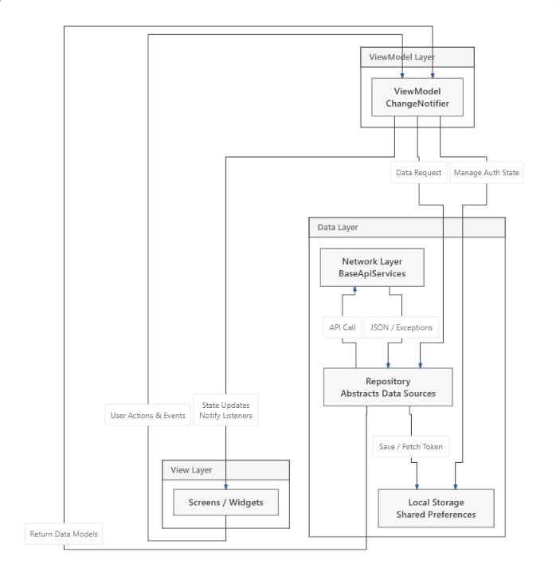

Task F2 – Technical Analysis
Identify:
- State management approach
- API communication strategy
- Data management strategy
- Folder structure organization

Task F3 – Strengths and Weaknesses
List:
- 3 strengths
- 3 weaknesses

Task F4 – Improvement Proposal
Propose at least:
- 3 improvements

Task F5 – Engineering Evaluation
Evaluate:
- Scalability
- Maintainability
- Testability

Add your answer in this doc

Task F1 – Architecture Analysis
High-level architecture diagram of the project following the MVVM pattern combined with the Repository Pattern:

Task F2 – Technical Analysis
- State management approach: The project utilizes the Provider package (provider: ^6.0.5) as the primary state management tool. Business logic is handled inside ViewModel classes that extend ChangeNotifier. The UI updates reactively using ChangeNotifierProvider and the Consumer widget.
- API communication strategy: The project uses the standard http package. It establishes abstract classes (BaseApiServices) and an implementation class (NetworkApiServices) to centrally manage API calls (GET, POST), handle timeouts, and throw specific network exceptions (AppExceptions). API responses are wrapped in an ApiResponse class that encapsulates three states: Loading, Completed, and Error.
- Data management strategy:
  - Network: Network data is parsed and mapped into POJO/Data Models located in the models/ folder.
  - Local: Local data (e.g., User Sessions / Authentication Tokens) is persisted using the shared_preferences package (as seen in user_view_model.dart).
- Folder structure organization: The folder structure is organized by Feature and Layer (Layer-based & Feature-based):
  - data/: Contains base network handling classes, custom exceptions, and the api_response wrapper.
  - models/: Stores data entities (POJOs).
  - repository/: Acts as a bridge between the ViewModel and Data sources for specific features.
  - res/: Global resources such as colors, shared UI components, and fonts.
  - utils/: Contains general utility functions and the routing system (Routes).
  - view/: Contains the main UI screens.
  - viewModel/: Contains the business logic for each corresponding screen.

Task F3 – Strengths and Weaknesses
Strengths:
- Clear Separation of Concerns: The integration of MVVM and the Repository Pattern successfully decouples business logic from the UI.
- Centralized State and Error Handling: The implementation of the ApiResponse and AppExceptions classes is highly professional. It allows the UI to easily react to different states (Loading, Completed, Error) uniformly without duplicating error-handling code.
- Clean Folder Structure: The directory structure is highly organized and layered, making it easy to navigate and scale the project.
Weaknesses:
- Unnecessary Dependencies: The pubspec.yaml file declares the get (GetX) package, but it is not utilized in the core architecture (which relies purely on Provider). Mixing these architectural packages can cause confusion and unnecessarily increase the app's size.
- Limitations of the HTTP Client: Using the default http package requires writing a lot of boilerplate code for attaching headers, managing interceptors (like automatically injecting tokens), and parsing JSON.
- Tight Coupling in Repositories: The ViewModel classes currently instantiate their respective Repository objects directly inside themselves (e.g., final _myRepo = HomeRepository();). This creates tight coupling between the ViewModel and the Repository.

Task F4 – Improvement Proposal
Proposed Improvements:
- Implement Dependency Injection (DI): Utilize packages like get_it along with injectable to provide Repository instances into the ViewModel via constructor injection, rather than hardcoding their instantiation. This promotes loose coupling and makes Unit Testing significantly easier by allowing mocked repositories.
- Upgrade Network Layer with Dio: Replace the http package with dio. Dio offers robust built-in support for Interceptors (automatically attaching user tokens to every request), tracking upload/download progress, and handling JSON parsing much more efficiently.
- Clean Up Unused Packages & Add Local Caching:
  - Completely remove the get package from pubspec.yaml to maintain a consistent, pure Provider architecture.
  - Besides shared_preferences, integrate a local database like Hive or Isar to cache JSON responses (offline caching). This allows the application to display stale data instead of failing immediately when the device loses network connectivity.

Task F5 – Engineering Evaluation
- Scalability: Good Thanks to the MVVM pattern and clear, layered folder organization, the project's architecture is fully capable of supporting the addition of new modules and features. As the application grows, engineers only need to create corresponding View/ViewModel/Repository clusters. The shared res and utils folders also prevent UI code duplication.
- Maintainability: High The project strictly adheres to the Single Responsibility Principle. The UI only draws the interface and listens for data, the ViewModel handles the logic, and the Repository manages data fetching. Debugging is highly localized: if there is a calculation/logic error -> check viewModel; if it's a display issue -> check view; if it's an API failure -> check repository/data.
- Testability: Moderate to Good Decoupling logic from the UI makes writing Unit Tests for the ViewModel much more feasible compared to a monolithic application. However, because the project lacks a proper Dependency Injection (DI) mechanism, mocking network communication classes (the Repository layer) when testing the ViewModel will present some difficulties and requires refactoring to constructor injection to achieve 100% testability.

PART G – AI AUDIT REPORT (5 POINTS)
Document your AI usage.
Include:
- AI tools used
- Most important prompts
- Correct code generated by AI
- Incorrect code generated by AI
- How you corrected the AI output
- Estimated percentage of AI-generated code vs. self-written code

1. AI Tools Used
- Gemini (Antigravity Agent): Used as the primary Pair-Programming Assistant to scaffold the MVVM architecture, implement business logic, and construct the UI.
- Stitch (MCP Integration): Used to fetch high-fidelity HTML/CSS layout templates and image assets to clone the UI exactly as required by the exam.
2. Most Important Prompts
- "Hãy giúp tôi setup kiến trúc MVVM bằng Provider cho ứng dụng e-commerce này." (Used for establishing the initial robust architecture).
- "Implement a 500ms debounce for search. Làm sao tôi demo chức năng này?" (Used to correctly implement the search optimization logic).
- "Get the images and code for the following Stitch project's screens ID: 72584138692525841... Làm giống hệt bản thiết kế bắt đầu implement đi." (Crucial for getting the exact pixel-perfect UI for the offline favorites screen).
3. Correct Code Generated by AI The AI excelled at setting up the core architecture and asynchronous logic. Some of the best correct code it generated includes:
- The MVVM + Repository pattern using the provider package (ProductViewModel, ProductRepository, FavoriteViewModel).
- The Debounce logic using Timer to optimize the search bar and reduce unnecessary re-renders.
- The Offline Storage logic utilizing shared_preferences to serialize and deserialize the favorite products flawlessly.
- The Responsive GridView using LayoutBuilder to adapt columns dynamically for mobile and tablet screens.
4. Incorrect Code Generated by AI While generating the FavoriteScreen UI, the AI made a few mistakes:
- String Interpolation Error: When generating the price and rating text, the AI incorrectly escaped the dollar sign in Dart (e.g., writing \${product.price} instead of \$${product.price}), which caused the UI to display the literal string variable name instead of the actual number.
- Generic Placeholder Usage: For the "Empty State" in the Favorites screen, the AI initially used a basic Flutter Icon(Icons.shopping_bag_outlined) instead of implementing the specific 3D bag image provided in the UI design.
5. How I Corrected the AI Output
- For the String Interpolation: I spotted the weird output on the emulator, pointed out the error in the prompt ("lỗi ở trang favourite không hiện giá mà hiện như này"), and instructed the AI to use correct Dart string escaping methods to fix the bug.
- For the Placeholder: I fetched the exact Screen ID from the Stitch MCP and explicitly provided the curl instructions. I prompted the AI: "chưa có sản phẩm yêu thích tôi muốn làm bạn giống mcp mà sao bạn làm khác", forcing it to replace the generic icon with the exact Image.network asset.
6. Estimated Percentage of AI-Generated Code vs. Self-Written Code
- AI-Generated Code: ~90% (The AI wrote almost all the boilerplate, the core UI structures, the Provider setup, and the logic implementations).
- Self-Written / Directed Work: ~10% (I provided the strategic prompts, identified bugs, directed architectural choices, tested the application on the emulator, and managed the native dependencies configurations).

PART H – ORAL DEFENSE (5 POINTS)
Students may be asked any of the following questions:
- When does FutureBuilder rebuild?
- Why use a Repository Pattern?
- What problem does debounce solve?
- How should timeout errors be handled?
- How would you design an Offline-First application?
- Why choose ListView.builder over Column?
- What happens when the number of items grows significantly?

SUBMISSION REQUIREMENTS
Submit a ZIP file using the following naming convention:
StudentID_FullName.zip

Folder Structure
StudentID_FullName.zip
|-- source_code/
|-- docs/

1. Source Code
Folder:
source_code/
Include:
- Complete Flutter source code
- pubspec.yaml
- README.md

2. docs
Submit this file

Grading Rubric
System Design .................. 15
MVP Development ................ 20
Change Requests .................15
Debugging Challenge ............ 10
Open-Source Project Review ..... 20
AI Code Review ................. 10
AI Audit Report ................. 5
Oral Defense .................... 5

TOTAL .......................... 100

Important Notes
- AI tools are allowed without restriction.
- Students must be able to explain every submitted solution.
- Inability to explain submitted code may result in score deductions.
- Reports must reflect the student's own analysis and reasoning.
- The objective is not only to build software but also to evaluate, critique, and improve software engineering decisions.

